4-（31） 新概念英语4 要点记住
31 The sculptor speaks 雕塑家的语言

Appreciation （of sculpture） depends upon the ability （to respond to form （in there dimension））. That is perhaps {表why sculpture has been described as the most difficult of all arts}； [certainly] it is more difficult than the arts （which involve appreciation of flat forms, 同位语shape in only two dimensions）.
（对雕塑的鉴赏力，取决于对立体的反应能力。雕塑被说成是所有艺术中最难的艺术，可能就是这个道理。欣赏雕塑品当然比欣赏平面的艺术品要难。）
·Appreciation of sculpture对雕塑的鉴赏。这里的介词of表示动宾关系，也就是说appreciation和sculpture虽然是两个名词，但appreciation是从动词appreciate派生出来的，sculpture实际上是appreciation的逻辑宾语。
- depend upon 依赖，依靠
- form n.外形，形态
————————————
- re-spond [rɪ-'spɒnd] v. 应对；作出回应；作出反应。回复；回答；回应
respond的基本意思是“报以…”“以…回答”“响应”,指用言语或行动对某事情作出有效的、良好的反应,往往用于书面或口头上的答复,引申可表示“有反应”“有影响”。
respond作不及物动词，表示“回答，响应”，后一般接to。
This modest group size allows our teachers to respond to the needs of each student. 这样的小组规模适中，可以使老师照顾到每一个学生的需求。
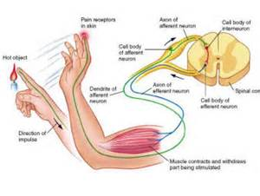
·Appreciation （of sculpture） depends upon the ability （to respond to form in there dimension）.
- to respond to form为「动词不定式」，作定语，修饰the ability，意即“对立体的反应能力”。
————————————
·[certainly] it is more difficult than the arts （which involve appreciation of flat forms, 同位语shape in only two dimensions）.
- involve
VERB需要；包含If a situation or activity involves something, that thing is a necessary part or consequence of it.
Running a kitchen involves a great deal of discipline and speed... 料理好厨房需要把一切都安排得规规矩矩，且要讲求速度。
Nicky's job （as a public relations director） involves spending quite a lot of time with other people. 尼基作为公共关系主管，需要花很多时间与别人打交道。
VERB使承担；使面对If one thing involves you in another thing, especially something unpleasant or inconvenient, the first thing causes you to do or deal with the second.
A late booking may involve you in extra cost... 预订晚了的话，你可能要额外多花钱。
This involved me in a round trip （of over 400 miles）. 为此我需要往返旅行 400 多英里。
————————————
·involve （常不用于进行时）vt.
（1）使陷人，使卷入。牵涉；涉及：
Don't involve me in your quarrel.不要把我卷入你们的争吵之中。
...a riot （involving a hundred inmates）...有 100 名囚犯参与的暴动（riot ['raɪət] n.骚乱，暴动，暴乱，骚动）
（2）必然带来。需要；包含：
This job involves a lot of travelling.这个工作需要经常旅行。
Nicky's job （as a public relations director）involves spending quite a lot of time with other people.尼基作为公共关系主管，需要花很多时间与别人打交道。

·[certainly] it is more difficult than the arts （which involve appreciation of flat forms, 同位语shape in only two dimensions）.
- in three dimensions为介词短语，作“定语”，修饰form，意即“三维的”。
- shape in only two dimensions 作 flat forms 的同位语，意即“只有二维的形状”。

Many more people are 'form-blind' than colour-blind. The child （learning to see）, first distinguishes only two-dimensional shape； it cannot judge distances, depths.
（“形盲”的人数比“色盲”的人数要多得多。正在学看东西的儿童，起初只会分辨二维形态，不会判断距离和深度。）
- many more 更多的……
- form-blind是作者仿照colour-blind（色盲）生造的一个词，意即“形盲”，故用引号引上。
- than 这里为介词，意思是“而不是”。
- colour-blind a.色盲的
- learning to see 作定语，修饰the child。learn to do sth. 学习做某事
- di-sting-uish [dɪ-'stɪŋ-ɡwɪʃ] v. 区分，辨别，分清；辨别是非
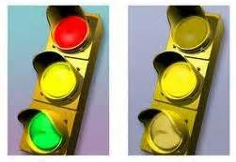
- it指 the child。
————————————
- judge
（L）vt.审判，审理..
The jury is judging the case.陪审团正在审理这个案子。
（2）vt.裁判：
He is going to judge the competition.他将裁判这场比赛。
（3）vt.判断，认为：
It’s unfair {to judge a man by his looks}.从外表来评判一个人是不公平的。
It is difficult {to judge whether he was right or wrong}.很难判断他究竟是对是错。
He judged the plan <to be impracticable>./ He judged {that the plan was impracticable}.他认为计划是行不通的。
（4）vi.裁判，判断，认为：
I'm not in a position （to judge）.我不站在能够做出判断的位置上。（即“我无法作出判断。”）
（5）n.（可数）审判官，法官，裁判，评判员：
The panel of judges consisted of a variety of famous people.评判组由许多知名人士构成。（panel ['pænl] n.（进行公开讨论或作决策的）专门小组。（机器、设备等的）仪表板，面板）
（6）n.内行，鉴赏家：
He is a good judge （of horses）.他善于相马。

Later, [目的状语for its personal safety and practical needs], it has to develop (partly by means of touch) the ability （to judge roughly three-dimensonal distances）. But [时间状having satisfied the requirements of practical necessity], most people go [no further].
（慢慢地，由于自身安全和实际需要，儿童必须发展（部分通过触觉）粗略判断三维空间距离的能力。但是。大部分人在满足了实际需要后，就不再继续发展这种能力了。）
- for its personal... needs为介词短语，作「目的状语」。it指the child。
- 括号中的内容是补充说明部分，说明孩子发展判断三维空间的能力是部分依赖触觉。
- by means of用…方法，依靠，如：
She tried to explain [by means of sign language].她试图用手势语进行解释。（sign符号；记号。（示意的）动作，姿势，手势）
- to judge...为「动词不定式」，作定语，修饰ability，意即“粗略判断三维空间距离的能力”。
————————————
·But [having satisfied the requirements （of practical necessity）], most people go [no further].
- But having satisfied the requirements of practical necessity 为分词短语，作「时间状语」。
- haveing satisfied 是「现在完成时」。其逻辑主语是most people。另外，这里也可以理解为省略了逻辑主语的「独立主格结构」。
- go further 就是“走的更远，继续前进，继续进步”。go no further就是“不再前进”。

[Though they may attain considerable accuracy （in the perception of flat from）], they do not make the further intellectual and emotional effort （needed to comprehend form （in its full spatial existence））.
（虽然他们对平面形的感觉，能达到相当准确的程度，但他们没有在智力和感情上，进一步努力去理解存在于空间的整个形态。）
- attain [ə'teɪn] vt.& vi. 达到，获得；遂愿；经过努力到达某事物
- accu-racy [ˈæ-kjə-rəsi] n. 精确（性），准确（性）

- per-ception [ pә-'sep-ʃәn] n.知觉；觉察（力）
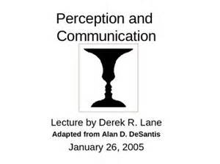
- in the perception of flat form 在对平面的感觉方面。
- effort n. 努力，尝试；气力；精力。（为达到某一目的的）有组织的行动，一系列活动

·[Though they may attain considerable accuracy （in the perception of flat from）], they do not make the further intellectual and emotional effort （needed to comprehend form （in its full spatial existence））.
- needed to comprehend form…existence为「过去分词短语」，作定语，修饰effort。
- com-pre-hend [ 'kɔm-pri-'hend] v.理解，领会

- spa-tial [ 'spei-ʃәl] a.空间的；受空间条件限制的
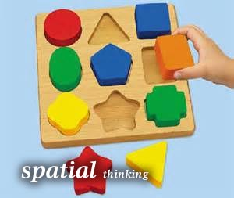
- in its full spatial existence 为介词短语，作定语，修饰 form，意即“存在于空间的整个形态”。
————————————
·effort
1.N-VAR努力；气力；精力If you make an effort to do something, you try very hard to do it.
He made no effort to hide his disappointment... 他毫不掩饰失望之情。
Finding a cure requires considerable time and effort. 找到治疗的办法，需要大量的时间和精力。
...his efforts （to reform Italian research）... 他为改革意大利研究，付出的努力
2.N-UNCOUNT吃力；费力If you say that someone did something with effort or with an effort, you mean it was difficult for them to do.
She took a deep breath / and sat up slowly / and with great effort... 她深吸一口气，费力地慢慢坐起身来。
With an effort she contained her irritation. 她努力强压住了怒火。
3.N-COUNT（为达到某一目的的）有组织的行动，一系列活动An effort is a particular series of activities that is organized by a group of people in order to achieve something.
...a famine relief effort （in Angola）. 在安哥拉进行的饥荒救济行动
4.N-SING费力的事；困难的事；劳神的事If you say that something is an effort, you mean that an unusual amount of physical or mental energy is needed to do it.
Even carrying the camcorder [while hiking in the forest] was an effort.
在森林中徒步旅行时，即便带的是便携式摄像机也非常费力。
5.PHRASE尽力；尝试；勉为其难If you make the effort to do something, you do it, even though you need extra energy to do it or you do not really want to.
I don't get lonely now [because I make the effort to see people]. 我现在不觉得孤独了，因为我尝试着与人交往。

This is {表从what the sculptor must do}. He must strive [continually] to think of, and use, form （in its full spatial completeness）.
（而雕塑家就必须做到这一点。他必须勤于想象，并且利用形体在空间中的完整性。
- strive [straɪv] vi. 努力奋斗，力求；斗争，力争
VERB努力；奋斗；力争；力求If you strive to do something or strive for something, you make a great effort to do it or get it.
He strives hard to keep himself very fit... 他努力地保持身体健康。
She strove to read the name （on the stone pillar）... 她费劲地读着石柱上的名字。
Mr Annan said {the region must [now] strive for economic development [as well as peace]}. 安南先生说，该地区现在必须为经济发展与和平而奋斗。
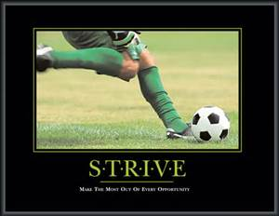
- strive to do sth.努力做某事，如:
All of us will continue striving to meet the very highest standards.
我们所有的人都应继续努力达到最高的标准。
————————————
·He must strive [continually] to think of, and use, form （in its full spatial completeness）.
- spatial [ˈspeɪ-ʃl] adj. 空间的；存在于空间的；受空间条件限制的；占大篇幅的
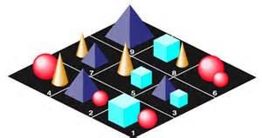
- com-plete-ness[kəm-'pli:t-nəs] n. 完全；完全性；完整性
- form in its full spatial completeness 作动词to think of 和use的宾语。其中的介词短语in its full spatial completeness作定语，修饰form，意即“想像并且利用形体在空间中的完整性”。

He gets the solid shape, 插入语as it were, inside his head ——he thinks of it, [让步状从whatever its size], 方式状从as if he were holding it completely <宾补enclosed in the hollow of his hand>.
（可以说，当他想象一个物体时，不管其大小如何，他脑子里得到的是一个立体的概念，就好像完全握在自己手心里一样。）
- as it were可以说是，作插入语。
- 破折号后面的he thinks of it，为同位语，解释说明前面的文字。
- whatever its size作「让步状语从句」，size后面省略了may be，意思是“不管其大小如何”。
- as if引导的是「方式状语从句」。在正式文体中，由as if引导的「方式状语从句」多用were，但在口语中也可用was，如：
He looked at me as if I were mad.他看着.我，就好像我疯了似的。
- enclosed in the hollow of his hand 作「宾语补足语」。
————————————
- enclose [ɪn'kləʊz] VERB包围；围住；封闭
Enclose the pot [in a clear polythene bag]... 将罐子装在透明的塑胶袋中。
The surrounding land was enclosed by an eight foot wire fence. 周围的土地围有8英尺高的铁丝栅栏。

·He gets the solid shape, 插入语as it were, inside his head ——he thinks of it, [让步状从whatever its size], 方式状从as if he were holding it completely <宾补enclosed in the hollow of his hand>.
- hol-low ['hɒ-ləʊ] adj. 空的；空心的；中空的；虚伪的；空腹的
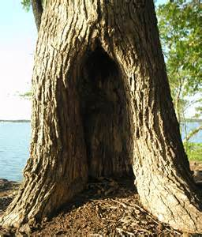
1.ADJ空的；空心的；中空的Something that is hollow has a space inside it, as opposed to being solid all the way through.
...a hollow tree. 空心的树
...a hollow cylinder. 中空圆筒
2.ADJ-GRADED凹的；凹陷的A surface that is hollow curves inwards.
He looked young, dark and sharp-featured, with hollow cheeks. 他看起来很年轻，肤色黝黑，五官分明，双颊凹陷。（cheek [tʃi:k] n. 脸颊，脸蛋；半边屁股）
3.N-COUNT树洞A hollow is a hole inside a tree.
I made my home there, in the hollow （of a dying elm）. 我在一棵快要枯死的榆树的树洞里，安了家。
4.N-COUNT凹陷处；低洼地A hollow is an area that is lower than the surrounding surface.
[Below him] the town lay warm in the hollow （of the hill）. 在他下方，小镇卧在温暖的山谷里。
...where water gathers in a hollow / and forms a pond. 在那里，水积聚在低洼处，形成了池塘
5.ADJ空洞的；无用的；无价值的If you describe a statement, situation, or person as hollow, you mean they have no real value, worth, or effectiveness.
Any threat （to bring in the police） is a hollow one. 任何威胁说要叫警察来的话，都是虚声恫吓。
...a hollow man （who's coasted on charm [for far too long]）. 长久以来，一直依靠个人魅力取胜的肤浅之人
hollowness
[One month before the deadline] we see the hollowness （of these promises）. 离最后期限只有一个月时，我们认识到了这些许诺都是空头支票。
6.ADJ（笑声等）虚伪的，不真诚的If someone gives a hollow laugh, they laugh in a way that shows that they do not really find something amusing.
Murray Pick's hollow laugh had no mirth in it. 默里·皮克的干笑里没有一点快乐。（mirth [mɜ:θ] n. <书>欢乐，欢笑）
————————————
·hold （held）
take hold of指“抓住”，比take hold（up）on常用；
hold sb by sth指“抓住某人的什么东西”。如，She held me by hand.她抓住我的手。
hold on to指“紧紧抓住”。如，Hold on to my arm.抓住我的手。
①vt.拿着，握住：
The dog held a newspaper in its mouth.那只狗嘴里叼着一张报纸。
→n.（可数，常用单数）握住，拿，托：
She kept a firm hold of her little boy’s hand [as they crossed the street].过马路时，她紧紧牵着她的小男孩的手。
→n.（常用单数）影响，控制，掌握：
He has a tremendous hold [over his younger brother].他对他弟弟有极大的影响。
→n.支撑物，可手攀的东西：
Can you find a hold for your hands [so that you pull yourself up] ? 你能不能找到一个手抓得住的地方爬上去？
→vt.支撑，承受：
The dam gave way，it was not strong [enough to hold the flood waters].水坝坍塌了，它的坚固程度不足以阻挡洪水。（dam [dæm] n.水坝，堰；水库。 give away v.撤退；让路；退让；垮掉）
②vt.保持（某种位置或状态）：
Hold yourself still for a moment [while I take your photograph].我给你拍照时别动。
→vi.保持某种状态，继续：
I fear {this beautiful weather won’t hold much longer}.恐怕这种好天气不会持续太久。
{What he said} still holds good.他说的话依然有效。
→vt.（不用于进行时）持有（看法等），认为：
He held the opinion {that the business was failing}.他认为生意正在走下坡路。
Therefore，I hold {that Tom ought to be informed}.因此，我认为应该通知汤姆。
He holds gambling <to be immoral>.他认为赌博是不道德的。（hold作“认为,相信； 保持,使…处于某种状态”解时,可接以“（to be）as+ n./adj.”充当「补足语」的复合宾语）
I hold parents responsible （for their children’s behaviour）.我认为父母应对子女的行为负责。（res-pon-sible [rɪ's-pɒn-səbl] adj.尽责的；承担责任；负有责任的；懂道理的。
一般来说，be responsible to后跟人，指“对某人负责”；而be responsible for后跟物，指“对某事负责”。
be responsible for表示“对……负责任”，它的主语不一定是人，这种用法在美式英语中较常见。如：
The cold weather is responsible for his absence.冷空气对他的缺席有一定的责任。）
→vt.占有，担任（职务）：
He holds 500 acres of land.他拥有500英亩土地。
She holds the office （of chairwoman）.她担任主席一职。（chair-woman
[ˈtʃeə-wʊmən] n.女主席，女议长）
→vt.容纳，装，盛：
This cinema can hold 1，500 people.这个电影院可容纳1，500名观众。
③vt.举行，召开：
They decided to hold a meeting next morning.他们决定第2天早上召开一个会议。

He [mentally] visualizes a complex form [from all （round itself）]； he knows [while he looks at one side] {what the other side is like}, he identifies himself [with its centre of gravity, its mass, its weight]； he realizes its volume, <宾补as the space （that the shape displaces [in the air]）>.
（他的大脑能从物体周围的各个角度，勾画出其复杂的形象，他看物体的一边时，便知道另一边是个什么样子。他把自身和物体重心、质量、重量融为一体。他能意识到物体的体积，那就是它的形状在空气中所占的空间。）
- men-tally [ˈmen-təli] adv. 心理上，精神上；智力上
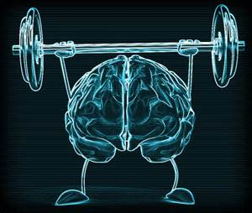
- visua-lize [ 'vi-zjuә-laiz] v.使具形象，设想；形成思维图像
- round adj.，adv.，表示“在周围，循环地”
- from all round itself从它的各个角度构想。该处介词用斜体，是为了强调。
- what the other side is like是动词knows的「宾语从句」。
————————————
·he identifies himself [with its centre of gravity, its mass, its weight]；
- i-denti-fy [aɪ-'dentɪ-faɪ] vt.

→认出；识别；分辨出；确定
I tried to identify her perfume... 我试图分辨出她用哪种香水。
A uniformed chauffeur identified me [among the crowd]. 一个穿制服的司机在人群中认出了我。（chauf-feur ['ʃəʊ-fə(r)] n. 受雇于人的汽车司机。vt. 开车运送；作（别人）司机。vi. 为别人当汽车司机）。
→VERB是…的标志；显示出If a particular thing identifies someone or something, it makes them easy to recognize, by making them different in some way.
She wore a little nurse's hat [on her head] to identify her... 她头戴一顶小护士帽，很容易辨认。
His boots and purple beret identify him as commanding the Scottish Paratroops. 他的长靴和紫色贝雷帽，表明他统领着苏格兰伞兵部队。（pur-ple ['pɜ:-pl] adj. 紫色的；帝王的；词藻华美的。n. 紫色；紫（红）衣，紫袍；帝位，皇权；皇族、vt. 使成紫色）
→VERB认同；理解；体会If you identify with someone or something, you feel that you understand them or their feelings and ideas.
She would only play a role [if she could identify with the character].. 她只愿扮演她能认同的角色。
I could speak their language / and identify with their problems [because I had been there myself]. 我会讲他们的语言，能体会他们的难处，因为我自己曾在那里呆过。
→VERB把…（与…密）切联系；认为…（与…）有关联If you identify one person or thing with another, you think that they are closely associated or involved in some way.
She hates playing the sweet, passive women （that audiences identify her with）... 她讨厌扮演那些漂亮可爱、消极被动的女人，观众们已把她定型为这类角色。（passive [ˈpæsɪv] adj. 被动的；消极的；不抵抗的；冷漠的）
The candidates [all] want to identify themselves with reform. 候选人都想把自己与改革，密切联系起来。
————————————
·he identifies himself [with its centre of gravity, its mass, its weight]；
- gra-vity [ˈgræ-vəti] n. 重力；万有引力，地心引力；重要性，严重性；严肃，庄重

- mass [mæs] n. [物理学]质量。大量，大多；块，堆，团；
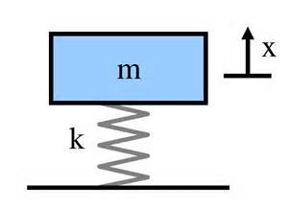
- identify … with：与…认同，与…融为一体，如：
She always identifies him with the liberals.她认为他与自由主义者有密切关系。
- 该句的意思是“他把自身和物体中心、质量、重量融为一体”。
————————————
·he realizes its volume, <宾补as the space （that the shape displaces [in the air]）>.
- as为介词，逗号表示停顿，以强调volume。
- that the shape displaces in the air 为「定语从句」，修饰 the space。
- volume [ˈvɒ-lju:m] n. 量，大量；体积；音量；卷
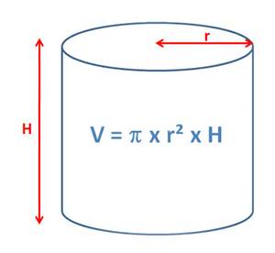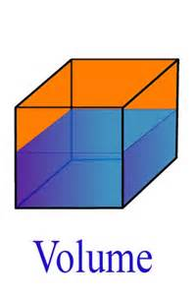
- dis-place [dɪs-'pleɪs] vt. 取代；代替；置换
These factories have displaced tourism as the country's largest source of foreign exchange... 这些工厂已取代旅游业，成为该国最大的外汇来源。 （tou-rism [ˈtʊə-rɪ-zəm] n. 旅游，观光；旅游业）

And the sensitive observer （of sculpture） must [also] learn to feel shape simply as shape, not as description or reminiscence. He must, for example, perceive an egg as a simple single solid shape, quite apart from its significance as food, or from the literary idea （同位that it will become a bird）.
（因此，敏锐的雕塑观赏者，也必须学会把形体作为形体来感觉，不要靠描述和印象去想象。以鸟蛋为例。观赏者必须感觉到它是一个单一的实体形态，而完全不靠它的食用意义，或它会变成鸟这样的文字概念来感觉。）
- sen-si-tive ['sen-sə-tɪv] adj. 敏感的；感觉的；[仪]灵敏的；易受影响的。n. 敏感的人；有灵异能力的人

- observer [əbˈzɜ:və(r)] n. ①观察者；观测者；目击者。②观察家；评论员
Observers say {the woman pulled a knife [out of the bunch of flowers] / and stabbed him in the neck}. 目击者说，那名女子从花束中拔出一把刀来，扎进了他的颈部。
Political observers believe {that a new cabinet may be formed shortly}. 政治观察家认为，新内阁可能很快就会组建。

·And the sensitive observer （of sculpture） must [also] learn to feel shape simply as shape, not as description or reminiscence.
- simply ADV简单地；只不过；仅仅；纯粹
- remi-ni-scence [ 'remi-'ni-sns] n.回忆，联想；旧事，回忆录
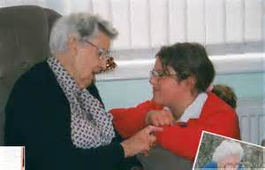
·He must, for example, perceive an egg as a simple single solid shape,
- per-ceive[pə'si:v]
1.VERB注意到，察觉，意识到（尤指不明显之物） If you perceive something, you see, notice, or realize it, especially when it is not obvious.
A key task is {to get pupils to perceive [for themselves] the relationship （between success and effort）}... 关键任务是让学生们自己认识到，成功和努力之间的关系。
'[Precisely] what other problems do you perceive?' she asked. “你究竟还发现了什么问题？”她问道。
2.VERB看作；视为；认为If you perceive someone or something as doing or being a particular thing, it is your opinion that they do this thing or that they are that thing.
Stress is widely perceived as contributing （to coronary heart disease）... 压力被广泛认为是导致冠心病的一个因素。（①stress [stres] n. 强调；重音；压力；重力。 ②con-tri-bute [kən-'trɪ-bju:t] vt.& vi. 贡献出；捐赠（款项）；投稿（给杂志等）；出力。 ③co-rona-ry ['kɒ-rən-rɪ] adj. 冠的，花冠的，冠状的；冠状动脉或静脉的。n. 冠状动脉；（病理学）冠状动脉血栓形成。）
They strangely perceive television as entertainment. 奇怪的是，他们居然将电视看作娱乐。
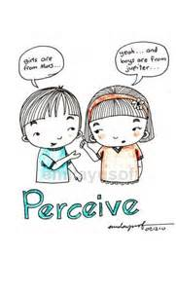
·He must, for example, perceive an egg as a simple single solid shape, quite apart from its significance as food, or from the literary idea （同位that it will become a bird）.
- perceive…as把…看作是，如：
I perceived her statement as a threat.我把她的声明看作是一种威胁。
————————————
- apart from撇开，除……以外，如：
He works until nine o’clock [every evening]，and that’s quite apart from the work （he does over the weekend）.他每天晚上都工作到9点钟，还未算他在周末干的活。
Apart from you and me，I don’t think there was anyone （there under thirty）.除了你和我，我认为那儿的人没有在30岁以下的。
————————————
- sig-ni-fi-cance[sɪg-ˈnɪ-fɪkəns] n. 重要性；意义；意思；重要性
A sacred site might be a mountain （that is of some significance to a tribe）. 对一个部落有重大意义的一座山峰，可能就是一处圣地。（sac-red [ˈseɪk-rɪd] adj. 宗教的；神圣的；受崇敬的，值得崇敬的；有宗教性质的）
quite apart from its significance... a bird 而完全拋开它的食用意义，或它会变成鸟这样的文学概念来感觉。
————————————
- lite-rary [ˈlɪtə-rəri] adj. 文学（上）的
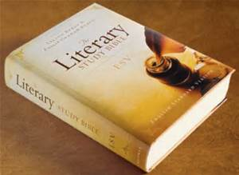
- that it will become a bird 是idea的「同位语从句」。

And [so with solids （同位such as a shell, a nut, a plum, a pear, a tadpole, a mushroom, a mountain peak, a kidney, a carrot, a tree-trunk, a bird, a bud, a lark, a ladybird, a bulrush, a bone）]. [From these] he can go on to appreciate more complex forms / or combinations （of several forms）.
HENRY MOORE The Sculptor Speaks from The Listener
（对于其他实体，如，贝壳、核桃、李子、梨子、蝌蚪、蘑菇、山峰、肾脏、胡萝卜、树干、鸟儿、花蕾、云雀、瓢虫、芦苇以及骨头，也应这样来感觉。从这些形体出发，观赏者可进一步观察更为复杂的形体，或若干形体的组合。）
- so with solids 中的 so ，指前面提到的to feel shape simply as shape，not as description or reminiscence （把形体作为形体来感觉，不要靠描述和印象去感觉），意即“对于其他实体也应这样来感觉”。
- such as用来列举一系列的实体。
- shell [ʃel] n. （贝、卵、坚果等的）壳；外壳；炮弹；（人的）表面性格

- nut [nʌt] n. 螺母，螺帽；坚果，坚果果仁；难对付的人
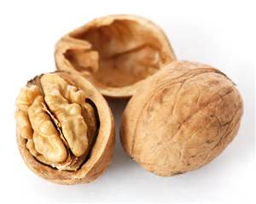
- plum [plʌm] n. 李子，李树；李属植物；葡萄干；紫红色。adj. 紫红色的；称心如意的（工作或职位）
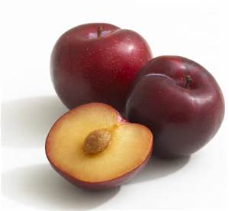
- pear [peə(r)] n. 梨（树）；梨树
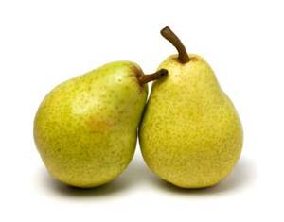
- tad-pole [ 'tæd-pәul] n.蝌蚪
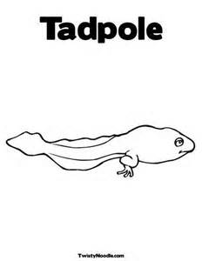
- mush-room [ 'mʌʃ-rum] n.蘑菇
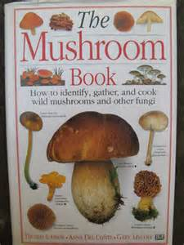
·And [so with solids （同位such as a shell, a nut, a plum, a pear, a tadpole, a mushroom, a mountain peak, a kidney, a carrot, a tree-trunk, a bird, a bud, a lark, a ladybird, a bulrush, a bone）].
- peak [pi:k] n. 山峰；最高点；尖端；帽舌

mountain peak山峰；巅
- kid-ney ['kɪd-nɪ] n. 肾，肾脏；（可食用的动物的）腰子；脾气，性格
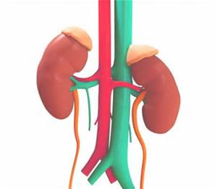
- car-rot [ 'kæ-rәt] n.胡萝卜；〈非正式〉好处，回报；不能兑现的报酬
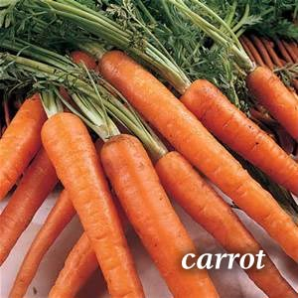
- bud [ bʌd] n.花蕾；未成熟的人，少男少女；〈美〉刚进社交界的姑娘
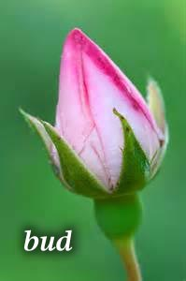
- lark [ la:k] n.云雀，百灵鸟
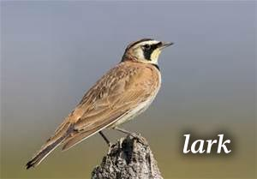
- ladybird n.瓢虫
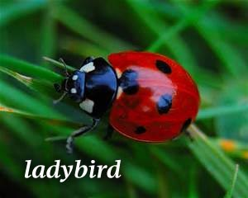
- bul-rush [ 'bul-rʌʃ] n.芦苇，香蒲，纸草；菖蒲

·[From these] he can go on to appreciate more complex forms / or combinations （of several forms）.
- combi-nation [ˌkɒm-bɪ-'neɪ-ʃn] n. 合作；密码组合；联合体；排列
n.结合；联合；混合A combination of things is a mixture of them.
...a fantastic combination （of colours）. 多种颜色的绝妙混合 （fan-tas-tic [fæn-ˈtæs-tɪk] adj. 空想的，异想天开的；奇异的，古怪的；极好的；不切实际的。n. 古怪的人）
...the combination （of science and art）. 科学与艺术的结合
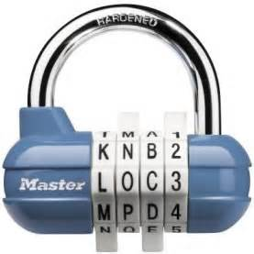

语法 Grammar in use
「动词不定式」用法（U）
名词+带to的「动词不定式」的用法
（1）作定语
当带to的「动词不定式」用于名词/代词之后时，通常起到「定语」的作用，修饰其前的名词/代词，如：
Our decision （to wait）was wise.我们决定等待是明智的。
It’s their wish （to succeed）.成功是他们的希望。
It’s fun （to be here）. 在这儿好玩。
It's a pity （to leave so early）.这么早走真是遗憾。
The person （to ask）is Jan.应该询问的人是简。
I’ve got an essay （to write）.我有一篇作文要写。（es-say ['e-seɪ] n.散文；随笔，杂记文）
I want something （to eat）.我想吃些什么东西。
There was a lot to do/a lot to be done.有大量的事要做。

然而，并非所有的“名词”都可以带「动词不定式」。有些名词的后面通常需要使用“介词+「动名词」结构”做定语，如：
There’s no hope （of finding him）.没有找到他的希望。
Thank you for your generosity /kindness （in contributing so much）.谢谢你如此慷慨/仁慈，给予这么多。（con-tri-bute [kən-'trɪ-bju:t] vt.& vi.贡献出；捐赠（款项）；投稿（给杂志等）；出力）

但有些则两者均可，如：
It s a pleasure （to be with you）.跟你在一起是愉快的。
There’s nothing to compare with the pleasure （of being with you）.跟你在一起无比愉快。

（2）形容词+名词+带to的「动词不定式」
在这样的句子结构中，主要应注意以下几种情况：
1）含too和enough时的使用方法
主要应注意不定冠词a/an的位置，和作为数量词的enough在there be句子中修饰名词时的位置，如：
He's too clever a politician （to say a thing （like that）in public）.他是一位非常聪明的政治家，绝不会在公开场合说那种话的。
He isn't a clever enough politician （to have any original ideas）.他不是一位聪明得能有任何创见的政治家。（①poli-ti-cian [ˌpɒlə-ˈtɪʃn] n.政治家；政客，玩弄权术者。②ori-ginal [ə'rɪ-dʒə-nl] adj.原始的；独创的；最初的；新颖的）
There is enough time / time enough （to take care of everything）.有足够的时间料理一切事情。

2）含so…as to和such... as to时的使用方法
主要应注意不定冠词a/an的位置，如：
I'm not so stupid （a fool）[as to put it in writing].
I m not such a （ stupid）fool [as to put it in writing].我不至于蠢到会把它写下来。
//————————————
注意so as to与so... as to的区别：
→so as to：意思是“为的是； 是为了； 以便”,与其后的动词原形一起作「目的状语」,用来强调目的。如：
Tomorrow my father will go to Beijing [so as to see his old friend].我父亲明天去北京是为了看望他的老朋友。
如果是表示否定目的,则要在“to”前加否定词not,即要用“so as not to”的形式。如:
Let's hurry up [so as not to be late for class].我们快点走吧,以免上课迟到。
in order to是so as to的同义词组,两者一般可互换使用。但是,当特别强调目的,且把「目的状语」放在句首时,只用in order to。例如:
In order to realize our dreams earlier, each of us must study even harder.为了早日实现我们的理想,我们每个人都必须更加努力地学习。
→so... as to：意思是“那么地……,以至……”, so后面接形容词或副词,在句中as to和其后的动词原形一起作「结果状语」。如:
The girl was so excited [as to shout herself hoarse].那个女孩兴奋得喊哑了嗓子。（或译为: 那个女孩是那么地兴奋,以至于嗓子都喊哑了。）
so... that 和so... as to虽然表示的意思几乎是一样的,而且两个so后面都是接形容词或副词,但它们所在的句子种类不同: so... that所在句子是带「结果状语从句」的「复合句」,而so... as to所在句子是「简单句」。当复合句的主句和从句的主语相同,而且从句又是表示肯定意思时,两者可互换使用。例如:
Just now they were so happy that they jumped.可改为: Just now they were so happy as to jump.刚才他们高兴得跳了起来。
————————————//

3）感叹句中冠词的位置
如下所示：
What an unkind thing to say !这话说得多么不客气呵！

